# What is static in java?

Static is a method that enables us to for example use a global variable inside the main method. But the weird thing is why can’t we access a global variable when it is technically inside the scope?

To access a global variable without the use of static we need to create an object of the class we are in.

Like this

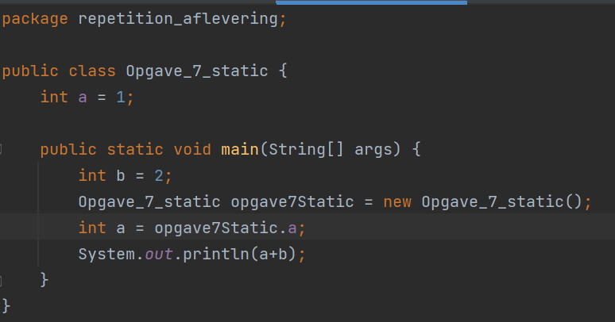

In my case, we also need the new value to a inside the scope. But doing it this way is very unnecessary and annoying, so the static method was invented so all we needed to do was write static in front the global variable. Like this

This way we avoid having to make an object just to we can use a global variable